**Yoobee College of Creative Innovation - Christchurch Campus**

**Diploma in Software Development 2202-Online-DSD**

**Finlay Macbeth** [**270177904@yoobeestudent.ac.nz**](mailto:270177904@yoobeestudent.ac.nz)

**Project Research, Redesign, and Develop a Webpage**

**Project Start Date: 9/03/2022**

**Project End Date: 27/03/2022**

Table of Contents

Strategy Phase 3

Introduction of the Client & Users 3

Client and business needs 3

Users needs 3

Clients Target Audience: 3

Competitor Analysis 5

Inspiration 8

Assumptions moving forward 8

Research Phase 9

Tasks for the User 9

Observations made during User tasks 9

User 1 Task Observations: 9

User 2 Task Observations: 9

User 3 Task Observations: 9

User 4 Task Observations: 9

User 5 Task Observations: 9

Qualitative questions 9

Quantitative questions 9

Analysis Phase 9

Contents 9

Design Phase 9

Contents 9

Bibliography 10

# Strategy Phase

## Introduction of the Client & Users

## Client and business needs

Our client is © 2022 Valve Corporation Steam. The client is an online platform for purchasing games, additional DLC game content, creating content, and discussing all relevant content. The client needs to be able to accumulate and retain users wanting to purchase Games and Content while making this an easy and enjoyable process.

## Users needs

The Clients’ users need to be able to quickly and easily locate games and content which are relevant and exciting to them, in a way that is logical and simple for the user. The user wants to be able to navigate efficiently and feel supported and catered to. Various alternatives are at their disposal such as relevant games or sales.

## Clients Target Audience:

Based on a survey conducted on Reddit, as well as an in-depth discussion with the client we collated data about the Clients Users as shown below.  
  
Platform used for Survey:  
<https://docs.google.com/forms/d/e/1FAIpQLSdxoglslP7QpqTDpyp8rlJJQw7FG9V_pigdpEQ0NEXrqwFSRA/closedform>

User Age:

Platform Visit Frequency:

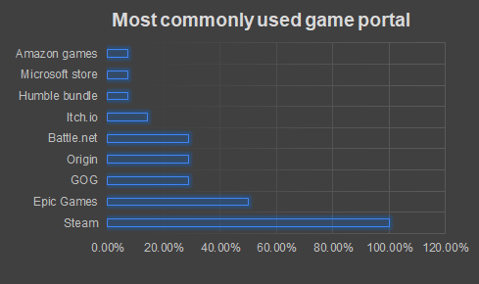Platform Preference:

Visual Theme Preference:

Number of Owned Games:

Based on the above survey findings the following assumptions have been made about the Clients Users:

* 57% of users are within the age range of 16-27.
* 43% of users browse for content on a weekly basis.
* Of the surveyed users 100% use Steam, 50% of which also use Epic games, other platforms are oocasionally used.
* 79% of users prefer to use a dark mode visual style, with Blue as a favourite colour for elements.
* 57% of users own either 31-70 games, 71-100 games, or 200+ games. With the exception of 7% of users, the rest of the users (about 36%) own more or less than the above figures.

In summary, most users are young adults, who browse for content weekly. They probably use Steam most often, prefer a darkmode which is easy on the eyes, and own a varied number of games, probably about 100.

This is our clients most likely target audience.

## Competitor Analysis

In order to analyse our competitors pain points and success points we will be taking a look at 2 examples from 2 competitors. These are Galaxy of Games, and Epic Games. We will look at their homepages, and 1 specific task for each, for this we have chosen a filtered search for First Person Shooter games, at $NZD 100.00 or less.

Following this analysis, we will take away from this with Inspiration going forward to help a redesign of our webpage for efficiency and enjoyment for the Clients’ users. We will have a clear understanding of pain points, , as well as success points to help determine the plausible fundamentals for the clients redesign.

Galaxy of Games:

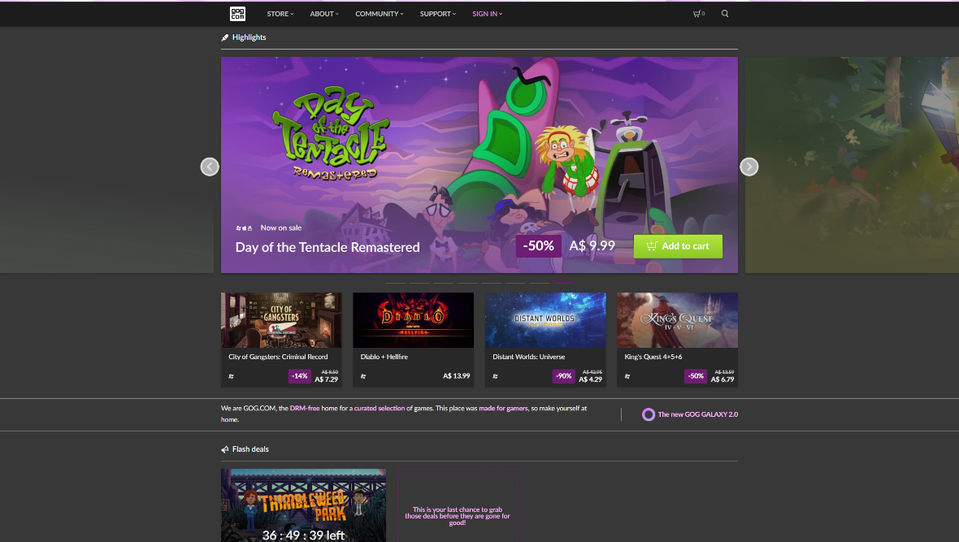Homepage

|  |  |
| --- | --- |
| Pros | Cons |
| Main menus are clearly visible at top | Features banner is too large and cannot be hidden |
| Each game clearly has a price, and a discount shown if applicable | There is very little content and no filters displayed to find games, due to the above con. |

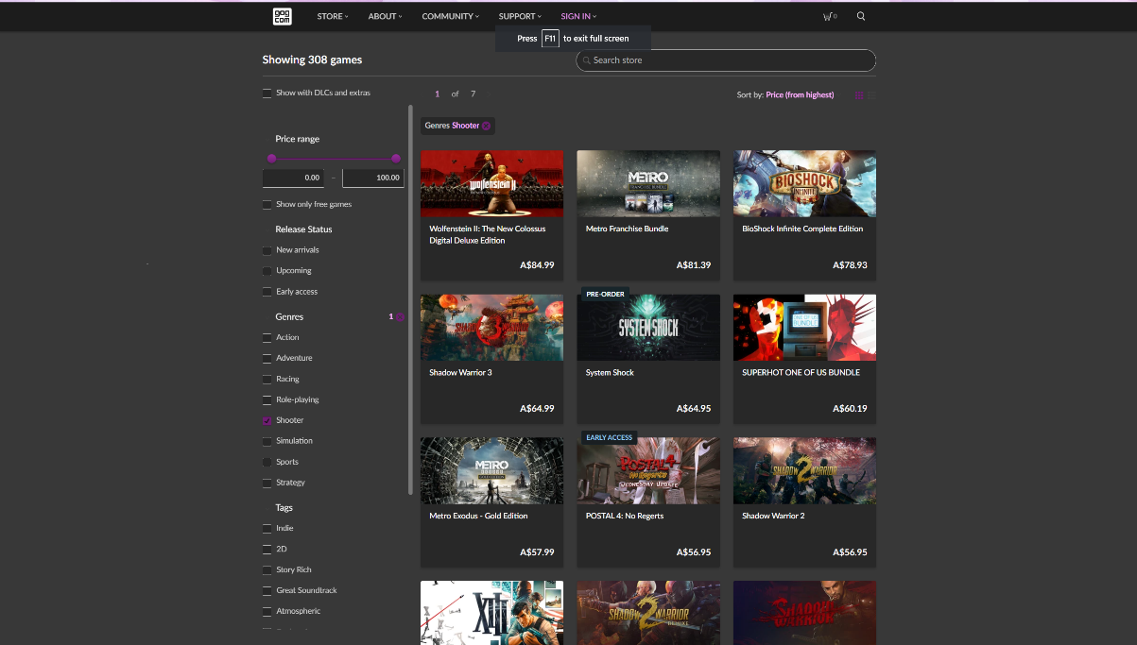First Person Shooter, $NZD 100.00 or less (search filters)

|  |  |
| --- | --- |
| Pros | Cons |
| Easily view content, and filters which are affecting what user sees | Can’t hover over a game for more information |
| No additional pop up or large content distracting from main content | Can’t hide and show the filters for more/less games viewable |

Epic Games:

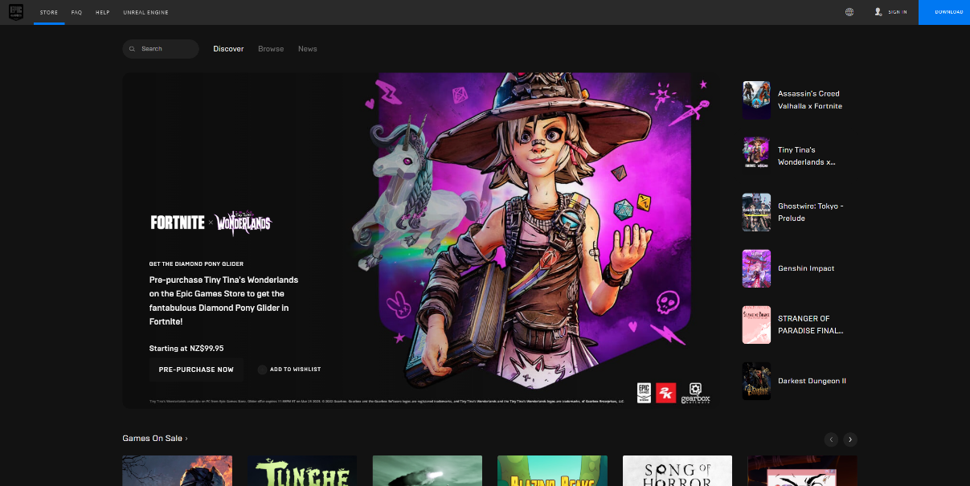Homepage

|  |  |
| --- | --- |
| Pros | Cons |
| Just like GoG, the main menus are easy to locate and use at the top | Also similar to GoG but even worse, is how large the featured content is, and no additional content is displayed properly, with no ability to hide the featured content. |
| Viewing the other featured content in mini next to the banner is a useful feature | The Search, discovery, browse features get lost a bit , perhaps enlarge or move |
| Getting the option to channel through the games on sale is a great space saving feature. | Language and sign in options at top right are too small, need to be larger to find easily. |

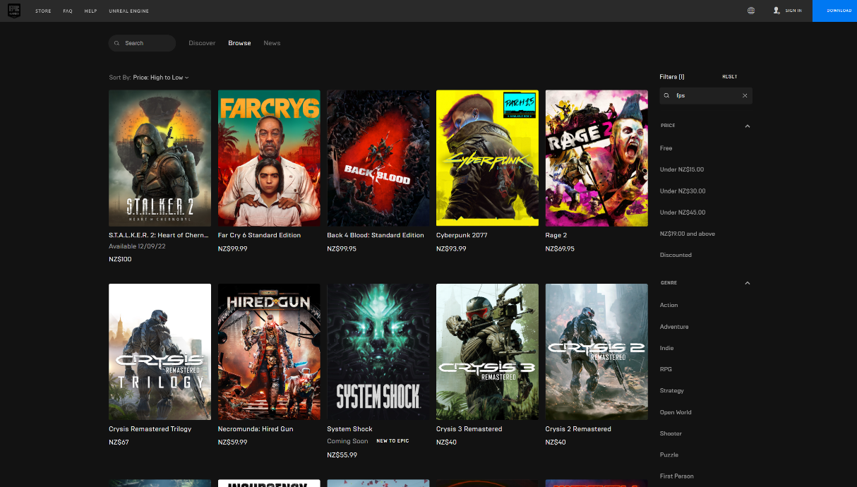First Person Shooter, $NZD 100.00 or less (search filters)

|  |  |
| --- | --- |
| Pros | Cons |
| Easily see ten choices right away | Price is difficult to see, as are discounts |
| Search and filters easy to see and use | Like GoG can not hover over game for more information |
| Can quickly reorganise with Sort By from above the games |  |

## Inspiration

In take away from the Competitor Analysis and the Clients own Website, some inherent inspiration we have found are as follows

* Featured content banners are often too large and take up valuable content space, also cannot be hidden
* Some menus are not easily visible or in the wrong location and get lost. This means potentially very useful features are overlooked or simply not used
* The most useful feature apparent from the competitors was the ability to apply and remove filters and sorting criteria to the displayed results, without navigating away from the page at all. You can constantly change your search criteria from A to Z and never once leave the page making direct comparison an enjoyable and speedy process.
* Placing main menus at top / centre helps to give bearing and navigation options to the user in a way that makes sense and does not confuse.
* A missing feature is more information on mouse over a game. This can be very handy to fill in gaps while keeping clutter off the page.
* A large and obvious button to link to the index is important, incase you find yourself lost on a separate page, and want to get back to the index.
* The ability to sign in or download the desktop client should be at top and bottom ribbon, easy access.

## Assumptions moving forward

Going forward, we can assume that the features banner needs to be generally smaller, and able to be hidden from sight on a timeframe easily chosen by the user based on their needs. Menus or features that are too small, or poorly placed can become lost. In contrast, menus which are enlarged and centred at the top or bottom are much more easily found. Allowing for filters and sortation functions to keep the user centred on one index page increases User Experience and helps the User with research and purchasing. It can feel detrimental to the experience without clear pricing / specials displayed, or no additional info displayed on mouse over.

Home button, sign in and download client should be clearly visible, preferably at the top.

# Research Phase

## Tasks for the User

To find pain points and successful aspects of the website, we chose five tasks for the users to complete to test and highlight possible fixes. These were as follows:

* Task 1: Find Cyberpunk 2077 store page
* Task 2: Find the discussion forums for Stardew Valley
* Task 3: Find the browsing page for RPG games under $20
* Task 4: Find out how to download the application
* Task 5: Find your games collection

## Observations made during User tasks

## User 1 Task Observations:

1. Used the search function. Instant result
2. Initially tried searching for it, found reviews first, not correct, then found view discussions on the side.
3. Struggled a lot to find the filters for games – it is not that easy to find
4. Installed Steam app immediately no issue
5. Initially missed the listed owned games, then struggled to find it. Eventually found it a minute later or so.

## User 2 Task Observations:

## User 3 Task Observations:

## User 4 Task Observations:

## User 5 Task Observations:

## Qualitative questions

## Quantitative questions

# Analysis Phase

## Contents

# Design Phase

## Contents

# Bibliography